Assignment 6 solutions :

**Using Special Operators in Conditions.**

1. Write two different queries that would produce all orders taken on October 3rd or 4 th, 1990.

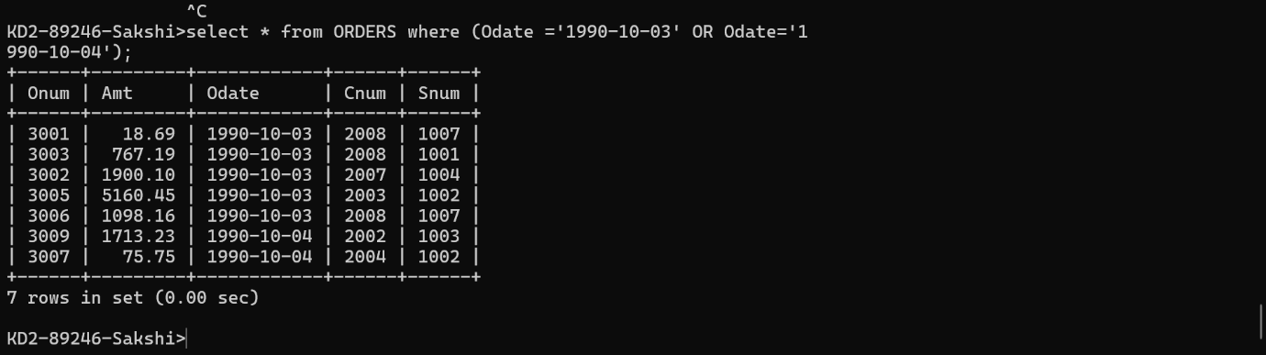

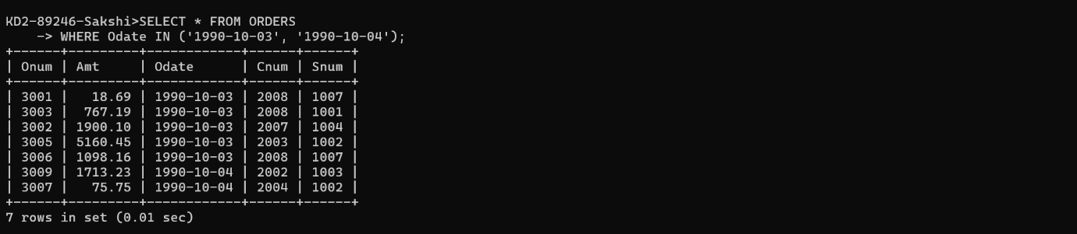

2) Write a query that selects all of the customers serviced by Peel or Motika.

(Hint: the snum field relates the two tables to one another).

**Select * from customers where Snum=1001 Or Snum=1004;**

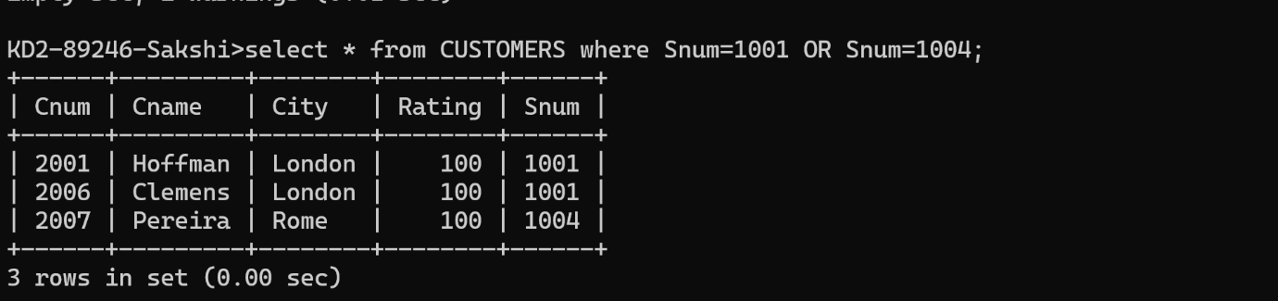

3) Write a query that will produce all the customers whose names begin with a letter from ‘A’ to ‘G’.

**Select * from CUSTOMERS where cname between ‘A’ and ‘G’;**

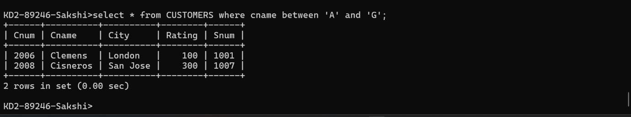

4) Write a query that selects all customers whose names begin with the letter ‘C’.

**Select * from CUSTOMERS where cname like ‘C%’;**

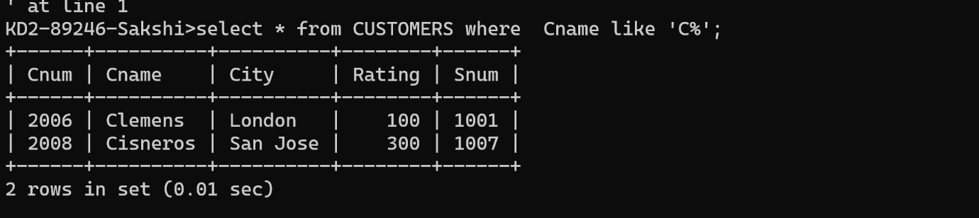

5) Write a query that selects all orders except those with zeroes or NULLs in the amt

**Select * from ORDERS where AMT!= NULL OR Amt!=0;**

